Chiral life and the electron spin

Yossi Paltiel

Applied Physics Department and the Center for Nano science and Nanotechnology, Hebrew University, Jerusalem 91904, Israel Paltiel@mail.huji.ac.il

Living organisms rely on chiral molecules, such as nucleic acids and proteins. A chiral molecule is not superimposable on its mirror image, also known as its enantiomer, just like our right hand cannot be superimposed on our left hand. Organisms contain only one enantiomeric form of a molecule, a selectivity that has prevailed through evolution. The chiral induced spin selectivity (CISS) effect studied by us [1], can explain why enantiomeric purity might provide an advantage in biology [2]. CISS is an electronic phenomenon in which electron transmission through chiral molecules depends on the direction of the electron spin, a quantum mechanical property associated with its magnetic moment. Thus, charge displacement and transmission in chiral molecules generates a spin-polarized electron distribution. This effect: enhance electron transfer in proteins, enable nano metric charge separation, and explain biorecognition [3].
The effect also explains the high efficiency of multiple electrons process in biology (light harvesting and respiration). This understanding can be utilized to increase the employment of green energy by enhancing the efficiency and selectivity of the production process. Thus, improving in a significant way the efficiency of electrolyzers, fuel cells, batteries, and solar cells [4].

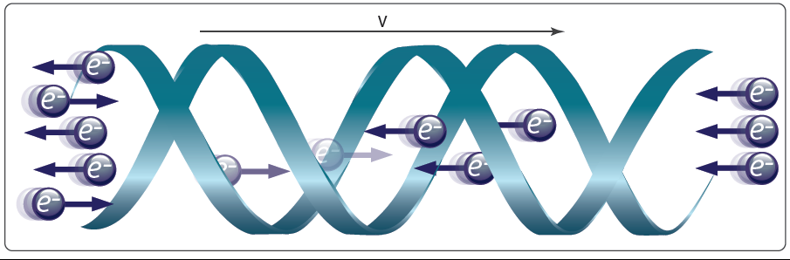
Figure 1: Schematics of the CISS effect; The Chiral induce spin selectivity (CISS) effect is an electronic phenomenon in which electron transmission through chiral molecules depends on the direction of the electron spin.

This effect can explain chiral symmetry breaking in the origin of life, as well as have interesting electronics applications for memory devices and green energy.

- Ron Naaman, Yossi Paltiel, David H. Waldeck; Chiral molecules and the electron spin; Nature Review Chemistry 3, 250–260 (2019) DOI: 10.1038/s41570-019-0087-1 (2019).
- K. B. Ghosh, O. Ben Dor, F. Tassinari, E. Capua, S. Yochelis, A. Capua, S.-H. Yang, S. S. P. Parkin, S. Sarkar, L. Kronik, L. T. Baczewski, R. Naaman, and Y. Paltiel; Enantio-Specific Interaction of Chiral Molecules with Magnetic Substrates Science 360, 1331 10.1126/science.aar4265 (2018).
- Yael Kapon, Abhijit Saha, Tal Duanis-Assaf, Thijs Stuyver, Amir Ziv, Tzuriel Metzger, Shira Yochelis, Sason Shaik, Ron Naaman, Meital Reches, and Yossi Paltiel, Evidence for New Enantiospecific Interaction Force in Chiral Biomolecules CHEM 7, 1–13 (2021). https://doi.org/10.1016/j.chempr.2021.08.002
- Wenyan Zhang, Koyel Banerjee-Ghosh, Francesco Tassinari, and Ron Naaman, Enhanced Electrochemical Water Splitting with Chiral Molecule-Coated Fe₃O₄ Nanoparticles ACS Energy Lett. 3, 2308−2313 (2018).

